The 24th Gathering of the Cornish Cousins
in Calumet, Michigan August 15 - 17

Please make sure that you make lodging accommodations immediately! Pasty Fest Weekend will be underway, and space will be booked early!

Details for specific events are still being finalized. This is also true for Pasty Fest information and some events on that webpage are not yet up to date.

This description will be a changing page on the CAHS Website (cousingjack.org). This is the information as it stands for mid-February.

Our headquarters for the Gathering will be at the Keweenaw Heritage Center at St. Anne’s, a truly perfect headquarters to meet, eat and share ideas and culture.
( https://keweenawheritagecenter.org/gallery-view.php?target=2 )

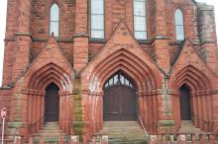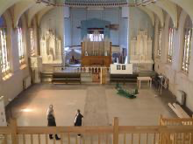

Wednesday evening: Registration at Keweenaw Heritage Center

Thursday morning: Registration at Keweenaw Heritage Center

Thursday: Visiting Calumet and the Four Heritage Sites

Get more information about the Keweenaw National Historical Park Visitor Center at https://www.nps.gov/kewe/index.htm and https://www.nps.gov/kewe/calumet-visitor-center.htm

- Coppertown USA Mining Museum
( https://www.nps.gov/places/coppertown-mining-museum.htm )
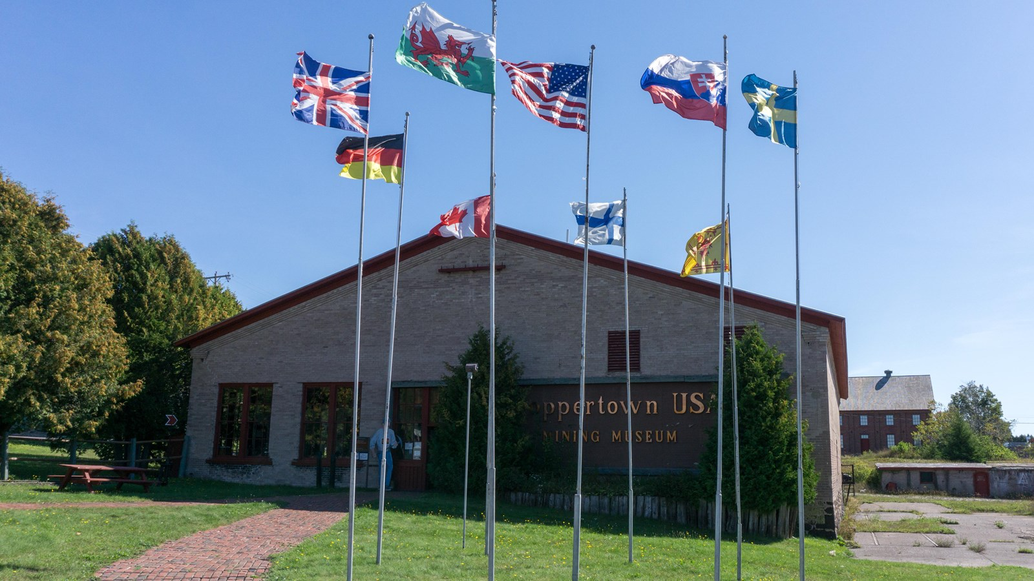

- Calumet Theatre ( https://www.calumettheatre.com/ )

- Keweenaw Heritage Society at St. Anne’s. ( https://keweenawheritagecenter.org/ )

- Upper Peninsula Firefighters Memorial Museum ( https://coppercountrytrail.org/destination/firefighters-museum )

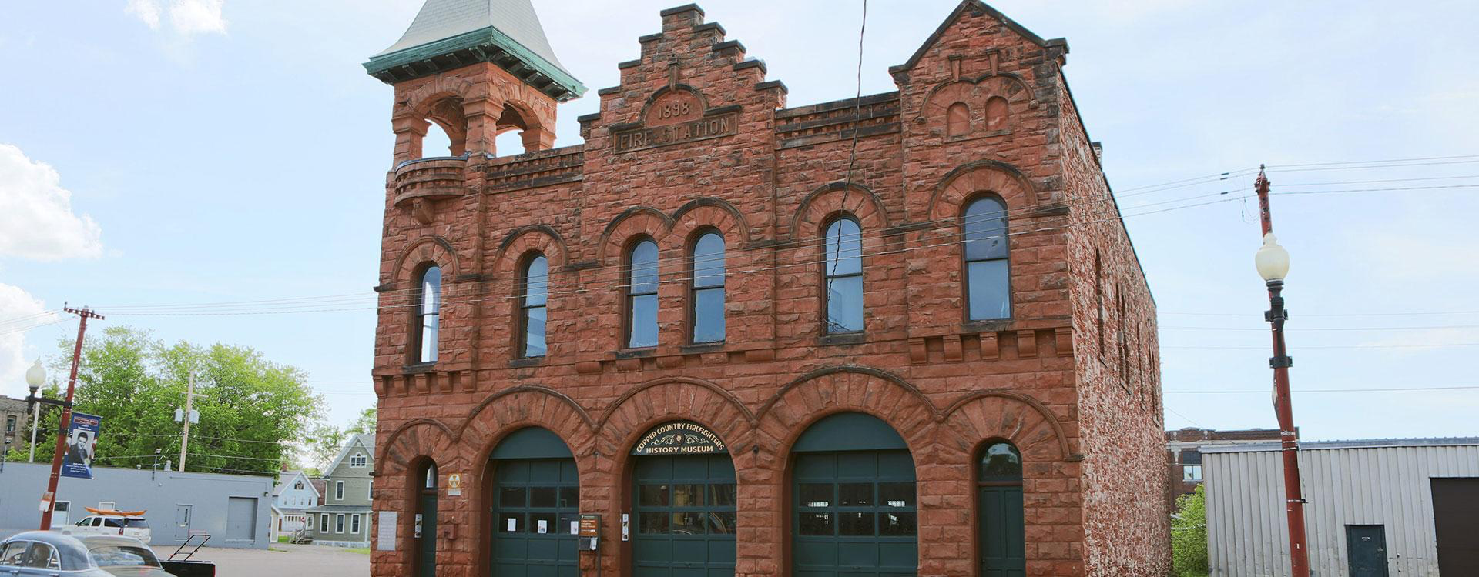

Thursday evening: Pasty Dinner at the Keweenaw Heritage Center

Friday morning: Presentations at the High School
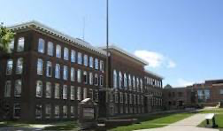
Friday afternoon: Keynote at Keweenaw Heritage Center
Jean Ellis has been in contact with Kate Neale and Joanie Willett as keynote speakers.
She reported that they are both excited and honored to present. They have the hope that they may appear in person. ( https://kateneale.co.uk/bio/ ) and
( https://politics.exeter.ac.uk/staff/willett/ ). The Keynote will either be in person or via Zoom.

We’re still looking into possible entertainment or speakers before or after the keynote.

Late Friday afternoon: High Tea at the Keweenaw Heritage Center

Friday evening: Concert at the Calumet Theatre.
( https://www.calumettheatre.com/ )
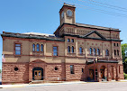

The 24th Gathering of the Cornish Cousins officially ends on Friday evening.

Saturday: Pasty Fest – On your own

The 20th Annual Pasty Fest is the all-day event on August 17th.
Different events and exhibits will take over Calumet.
The Car Show will include cars from near and far and will be a fund raiser for the Keweenaw Heritage Society at St. Anne’s ( https://www.mainstreetcalumet.com/cool-cars-car-show.html )

Pasty Fest Art Prize – Artists from across the Upper Peninsula have an opportunity to submit pasty-themed artwork. The pieces and installations will be displayed in local Calumet businesses, allowing Customers and community members to explore Calumet’s gorgeous, historic downtown and vote on their favorite pieces.
( https://www.mainstreetcalumet.com/pasty-fest-art-prize.html )

Pasty Fest Olympics –
Includes a Pasty Bake Off ( https://www.mainstreetcalumet.com/pasty-bake--off.html ),
A Pasty Fest Eating Competition ( https://www.mainstreetcalumet.com/pasty-eating-competition.html ),

And other events, especially vendors and music, as well as kids’ activities
( https://www.mainstreetcalumet.com/attend.html ).

